EPX NO 3:

Create a Virtual Hard Disk and allocate the storage using VM ware Workstation.

DATE:

AIM:

To create a virtual hard disk and allocate the storage using vm ware workstation

PROCEDURE:

STEP 1: GOTO VM WARE WORKSTATION.

STEP2: RIGHT CLICK THE VM AND GOTO THE SETTINGS.

STEP 3: ADD HARDWARE WIZARD AND SELECT SCSI AND CLICK NEXT.

STEP 4: CREATE NEW VIRTUAL DISK.

STEP 5: SELCT THE DISK SIZE AS 2.0. AND SELCT SPLIT VIRTUAL DISK INTO MULTIFILES.

STEP 6: GIVE NAME AND CLICK THE FINISH.

IMPLEMENTATION:

STEP 1: GOTO VM WARE WORKSTATION

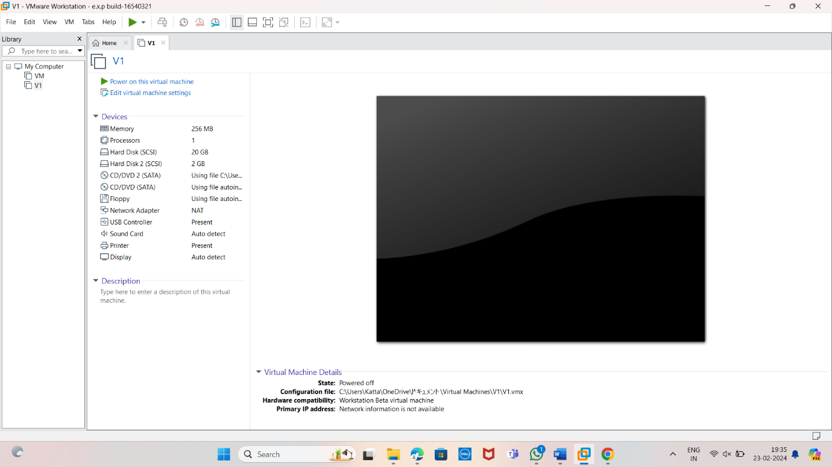

STEP2: RIGHT CLICK THE VM AND GOTO THE SETTINGS.

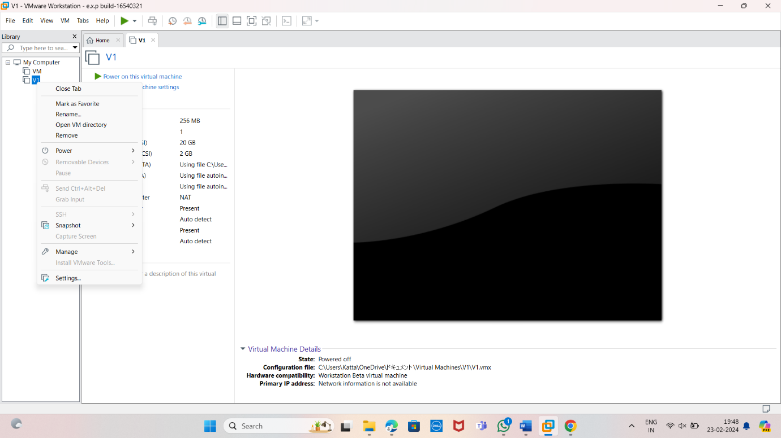

STEP 3: ADD HARDWARE WIZARD AND SELECT SCSI AND CLICK NEXT.

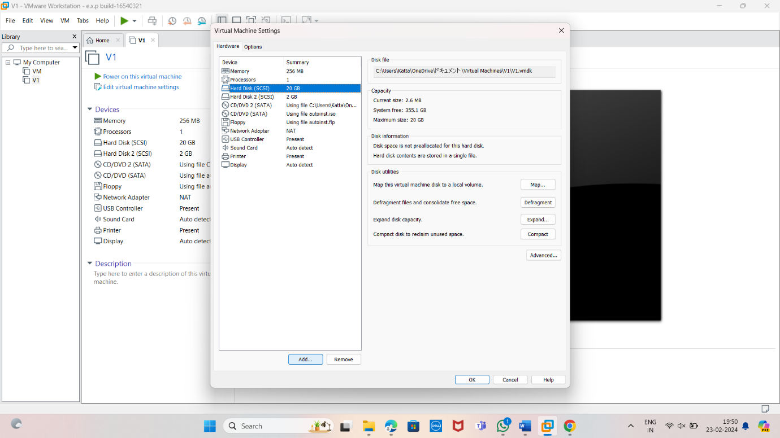

STEP 4: CREATE NEW VIRTUAL DISK.

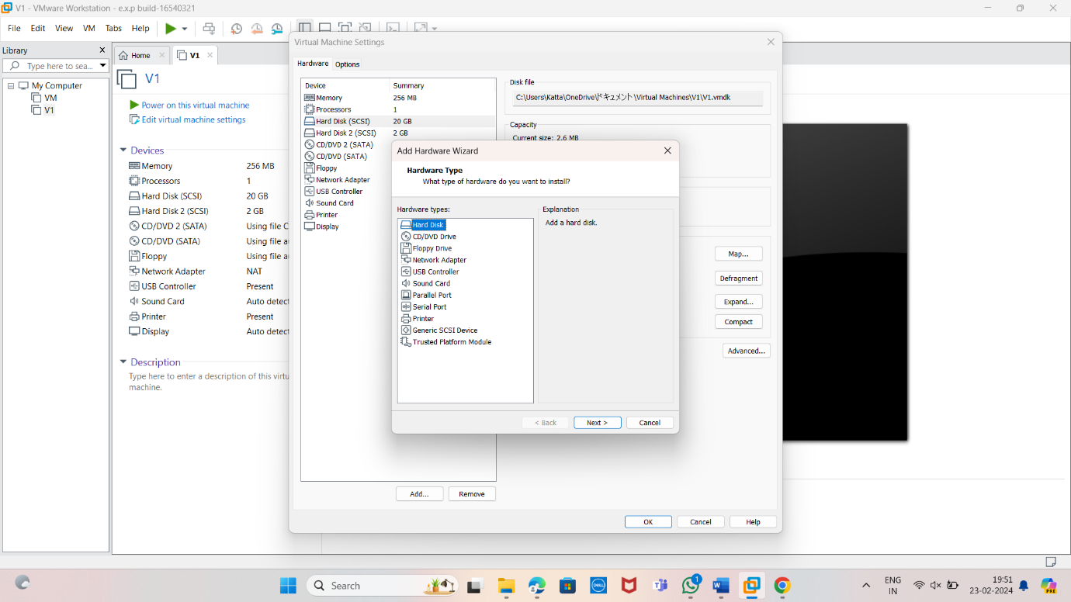

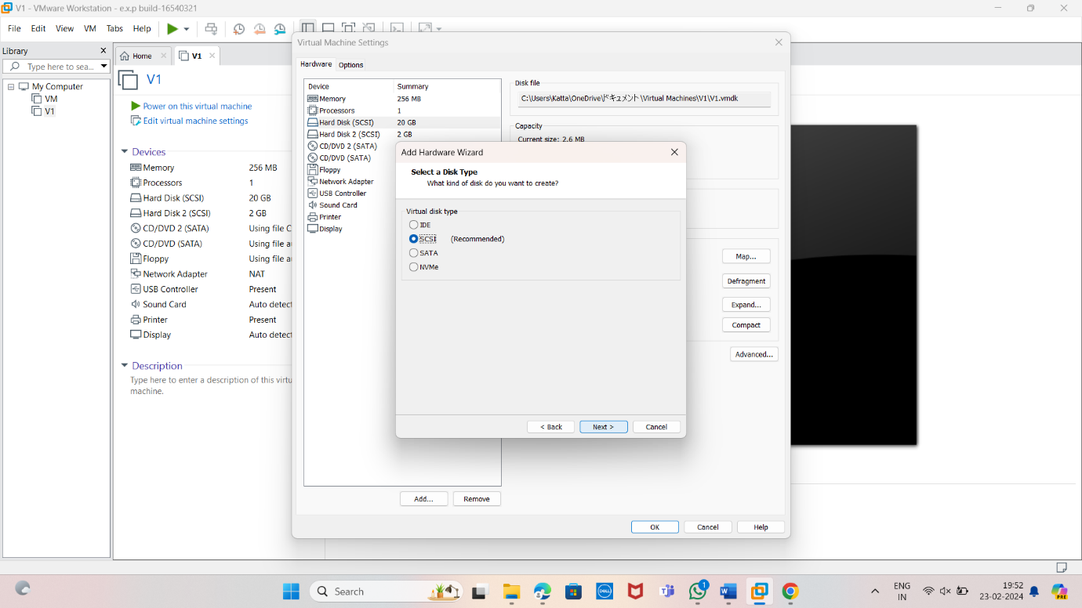

STEP 5: SELCT THE DISK SIZE AS 2.0. AND SELCT SPLIT VIRTUAL DISK INTO MULTIFILES.

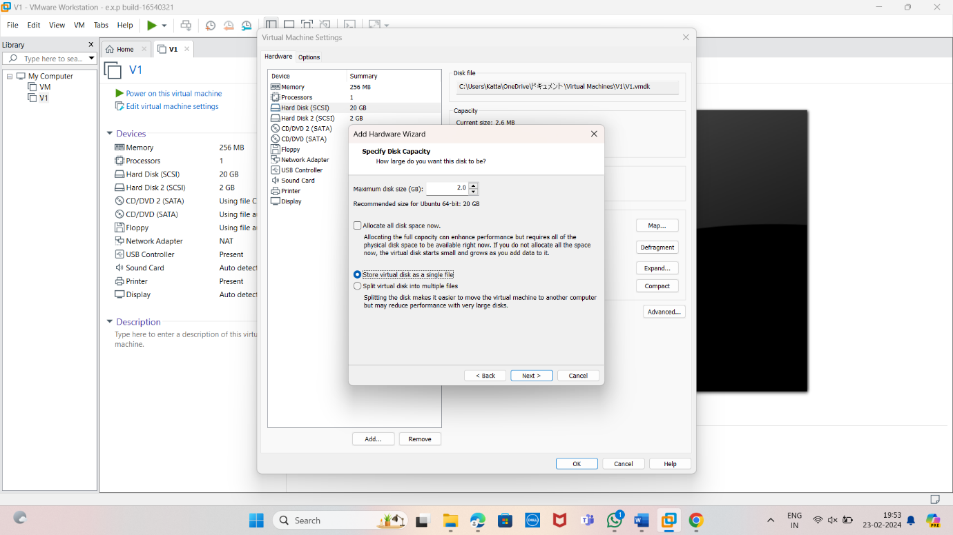

STEP 6: GIVE NAME AND CLICK THE FINISH.

